**To Whom It May Concern,**

This is to certify that I, the undersigned, have thoroughly reviewed and verified that all the required documents related to the project titled:

**"_Plant Disease Detection by using Mobile Application_"**

have been successfully uploaded to the designated GitHub repository.

* **GitHub Repository URL:** [<https://github.com/Hasnain0295/FYP2_Plant_Disease_Detection-Dataset_Working-.git>]
* **Team/Student Name(s):** [Syed Hasnain Imran, Khadija Rashid Mughal, Zainab Jamil]
* **Department:** **Department of Computing, FEST**
* **Institution:** **Hamdard University**

The uploaded materials include (but are not limited to):

* Project source code
* Project report/documentation (Proposal/SRS/SDS/Report/Test Plan)
* Presentation slides
* Dataset(s) (if applicable)
* Poster/Video of Demo
* Any supporting files as required by the submission guidelines

I confirm that the submission complies with the documentation requirements outlined for this project/course and is accessible on the mentioned repository.

This certificate is issued for record-keeping and official use as part of the project evaluation or academic requirements.

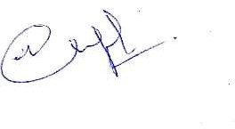**Supervisor Name:** Mr. Waqas Pasha  
**Designation:** **ABC** **Signature (Compulsory):**   
**Date:** **05/07/2025s**